**OpenStreetMap Sample Project**

**Data Wrangling with MongoDB**

**Lucas Mwai**

Map Area: Marietta, GA, United States

<https://www.openstreetmap.org/export#map=12/33.9486/-84.5425>

Overpass API node (-84.7169,34.0316, -84.3681,33.8656)

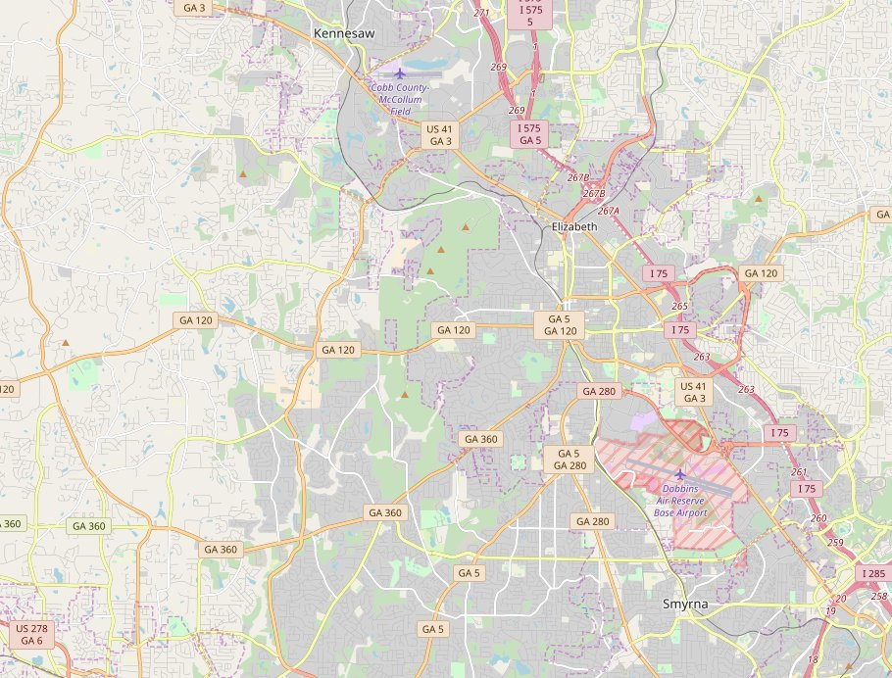

This project seeks to apply data Wrangling techniques to analyze and clean Open Street Map data for the selected area and then perform an exploratory analysis of the data after importing it into a MongoDB collection.

The area I am presenting covers part of North Atlanta in the state of Georgia. The area has several counties and covers some zip codes mainly in cobb and Fulton counties in the Atlanta suburbs. I chose this area because I am currently residing here and I was curious what insights the data could unravel to me and I will share the insights in this project. It should be interesting for me to work with some of the streets that I have personally driven through and I will hopefully understand the area better.